MADHU SATYA KIRAN MANEPALLI

Analyst

# Education and certificates

Bachelor of Technology (2018 – 2022)

Computer Science and Engineering

**Skills**

**Base Location:**

CHENNAI

Java 11

Spring Boot, MVC

**Email ID: Mobile No:**

[MADHU.SATYA-KIRAN-MANEPALLI@CAPGEMINI.COM](mailto:MADHU.SATYA-KIRAN-MANEPALLI@CAPGEMINI.COM)

+91 70950 01796

Spring Security Spring Cloud

**Grade:** A4

# Strengths Achievement

**Full Stack Developer**

# Coupons and Deals Finder Application

* Hands on experience in creating **microservices** with **Spring**

**MEAN Stack** Angular MongoDB

**Database**

SQL database – MySQL

No SQL database – MongoDB

**boot, Spring Security, Spring API Gateway,** Eureka server

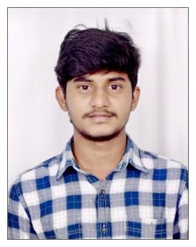

* Hands on experience in creating single page web application
* **Java Microservice** Development knowledge using **Spring boot and spring cloud** framework on an intermediate level.
* Team player who communicates effectively and works well with others to improve work output.
* Eager to improve myself by learning new technologies and increasing my overall skills.
* Completed end to end Deals and Coupons case study using Java Full Stack with Angular.
* Implemented Multiple Micro services using Spring Boot and Spring Cloud and connecting them via a Discovery Server i.e. Eureka. Including routing using Netflix ZULL as a API Gateway and used SWAGGER Documentation.
* Frontend with Angular 12, using Angular CLI for creating a

user-friendly UI.

* Backend with Mongo Compass.

# Completed the Capgemini ADAPT Java Full Stack Angular training.

**Web Technologies**

HTML5 & CSS3

Javascript Typescript

**AddOns** Github Maven Postman VS Code

**Additional Details** Communication Skills Team management